

LAB REPORT

MUHAMMAD LUTFIL HADI BIN MOHD HAFEZ CBS24070032 CBS5





Table of Contents

Lab exercise 1 2

Question 1 Hello World 2

Lab exercise 2 3

File Structure 3

Question 1 BMI calculator 3

Lab exercise 3 8

File Structure 8

Question 1 Grade Program based on marks using if else 8

Question 2 Arithmetic Operator chosen with Switch Statements 13

Lab exercise 4 20

File Structure 20

Question 1 Loop Structure to calculate sum of 1 to 10 21

Question 2 Sum of Odd and Even integers from 1 to 10 25

# Lab exercise 1

## Question 1 Hello World

**QUESTION**

Write your first “Hello World” Java coding.

**CODING**

Text form

public class App {

    public static void main(String[] args) throws Exception {

        // printout "Hello World"

        System.out.println("Hello, World!");

    }

}

Screenshot from VS Code

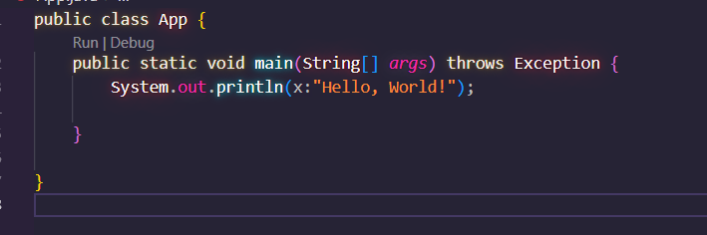

**OUTPUT**

Screenshot the output

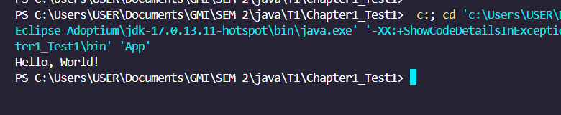

# Lab exercise 2

### File Structure

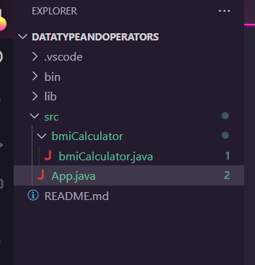

Task is put onto different package file. App.java contain main method.

### Question 1 BMI calculator

**QUESTION**

Write an interactive Java program that calculate the user’s BMI (Body Mass Index). Identify the input data and display the output.

**CODING**

Two files will be shown for coding:

1. App.java file
2. bmiCalculator.java

App.java file:

Text form

import bmiCalculator.bmiCalculator;

public class App {

    public static void main(String[] args) throws Exception {

        double bmiResult;

        //call class function

        bmiCalculator bmiCalculatorProgram =  new bmiCalculator();

        //execute

        bmiResult=bmiCalculatorProgram.bmiCalculatorfunc();

        if (bmiResult > 0  && bmiResult < 18.5) {

            System.out.println("BMI is " + bmiResult +".\nYou are underweight");

        }

        else if (bmiResult >= 18.5  && bmiResult <=24.9) {

            System.out.println("BMI is " + bmiResult +".\nYou are healthy");

        }

        else if (bmiResult >= 25.0  && bmiResult <=29.9) {

            System.out.println("BMI is " + bmiResult +".\nYou are ovreweight");

        }

        else if (bmiResult >= 30.0) {

            System.out.println("BMI is " + bmiResult +".\nYou are obese");

        }

    }

}

VS Code screenshot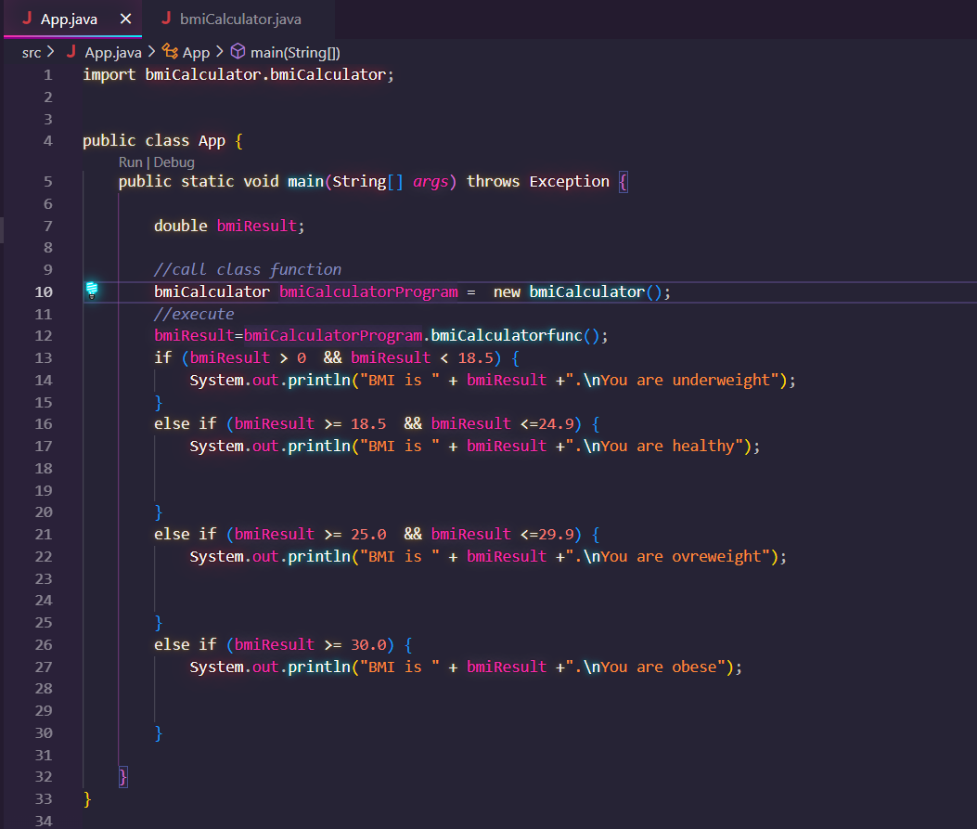

bmiCalculator.java file:

import bmiCalculator.bmiCalculator;

public class App {

    public static void main(String[] args) throws Exception {

        double bmiResult;

        //call class function

        bmiCalculator bmiCalculatorProgram =  new bmiCalculator();

        //execute

        bmiResult=bmiCalculatorProgram.bmiCalculatorfunc();

        if (bmiResult > 0  && bmiResult < 18.5) {

            System.out.println("BMI is " + bmiResult +".\nYou are underweight");

        }

        else if (bmiResult >= 18.5  && bmiResult <=24.9) {

            System.out.println("BMI is " + bmiResult +".\nYou are healthy");

        }

        else if (bmiResult >= 25.0  && bmiResult <=29.9) {

            System.out.println("BMI is " + bmiResult +".\nYou are ovreweight");

        }

        else if (bmiResult >= 30.0) {

            System.out.println("BMI is " + bmiResult +".\nYou are obese");

        }

    }

}

VS Code Screenshot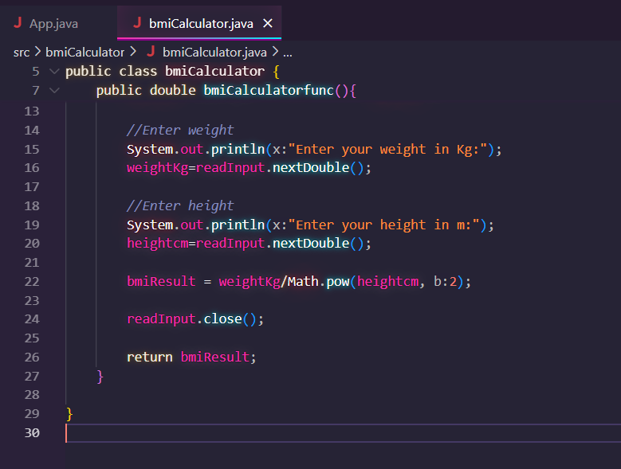

**OUTPUT**

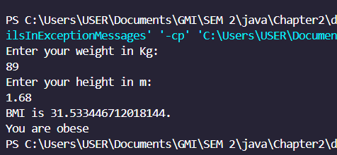

# Lab exercise 3

## File Structure

Each task is divided into packages.

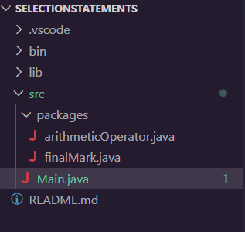

Main code is executed within Main.java file. Each class method is uncommented to call the program.

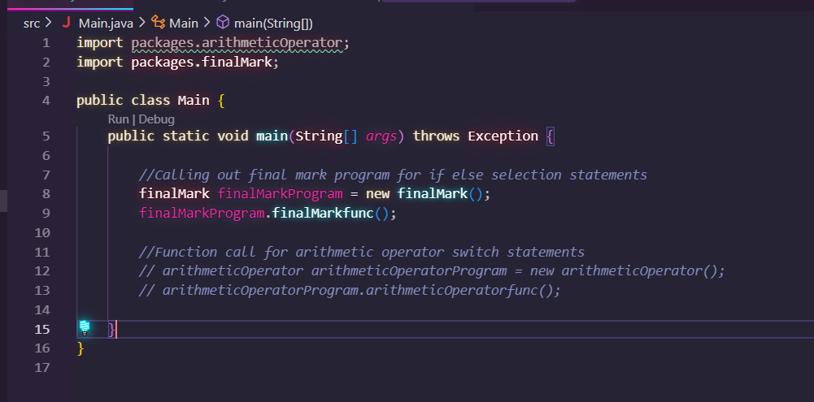

## Question 1 Grade Program based on marks using if else

**QUESTION**

Write a java program by using “if..else if” statement to display the Grade based on the mark calculated from the user’s input.

**CODING**

Text form

package packages;

import java.util.Scanner;

public class finalMark {

    // establish function for finalmark program

    public void finalMarkfunc() {

        // Variable for user input to exit the program or not

        String loopExit;

        // final mark declared below

        int averageMark = 0;

        // variable for input

        int test1, test2;

        // variable for name

        String userName, userID, subject;

        while (true) {

            // Establish the input scanner

            Scanner readUserInput = new Scanner(System.in);

            // Enter name

            System.out.println("Enter name:");

            // read name

            userName = readUserInput.nextLine();

            // Enter ID

            System.out.println("Enter ID:");

            // read ID

            userID = readUserInput.nextLine();

            // Enter Subject

            System.out.println("Enter Subject:");

            // read Subject

            subject = readUserInput.nextLine();

            // Enter Test1

            System.out.println("Enter Test1 Marks:");

            // read Test1

            test1 = readUserInput.nextInt();

            // Enter Test2

            System.out.println("Enter TeST 2 Marks:");

            // read test2

            test2 = readUserInput.nextInt();

            //calculate averagemark

            averageMark = (test1 + test2) / 2;

            // print all information

            System.out.println("\nName:\t\t" + userName + "\nID :\t\t" + userID + "\nSubject:\t" + subject

                    + "\nAverage Mark :\t" + averageMark+"\n\n");

            //if else statements to determine grade

            if (averageMark > 0 && averageMark <= 40) {

                System.out.println("Final grade:D");

            } else if (averageMark <= 60) {

                System.out.println("Final grade:C");

            } else if (averageMark <= 85) {

                System.out.println("Final grade:B");

            } else if (averageMark <= 100) {

                System.out.println("Final grade:A");

                //error printn for wrong marks

            } else {

                System.out.println("Invalid marks");

            }

            // call user to end the application

            System.out.println("\nExit application?(y/n)");

            // Input to enter to exit or no

            loopExit = readUserInput.next();

            // if string is y

            if (loopExit.equals("y")) {

                // close scanner,

                readUserInput.close();

                // exit program

                break;

            } else {

                //continue using the program

                continue;

            }

        }

        System.out.println("Bye");

    }

}

VS Code Screenshot

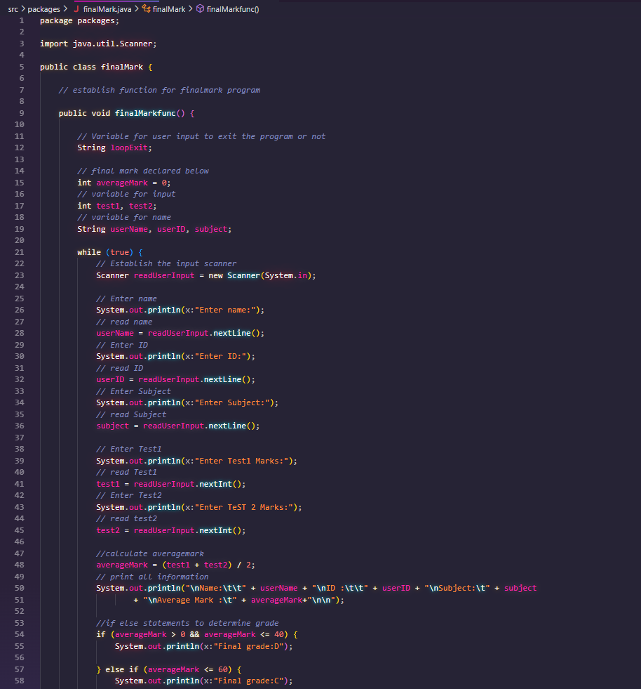 

**OUTPUT**

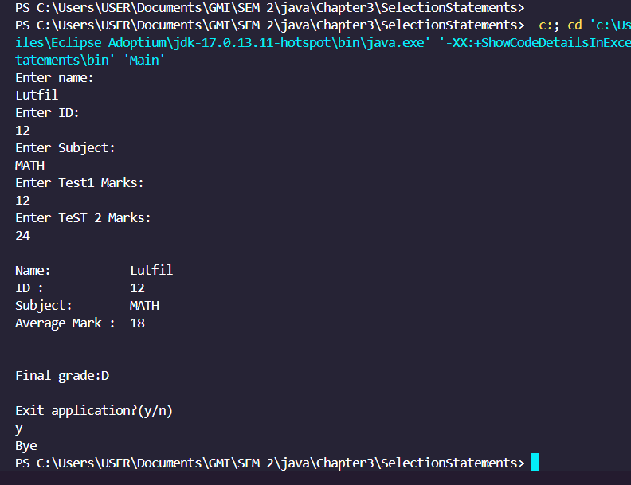

## Question 2 Arithmetic Operator chosen with Switch Statements

**QUESTION**

Modify the Arithmetic Operation program. In addition, allow user to choose the arithmetic operator from a menu given. Display the result of the arithmetic operation based on the user’s input. Apply Switch statements.

**CODING**

Text form

package packages;

import java.util.Scanner;

public class arithmeticOperator {

    public void arithmeticOperatorfunc() {

        Scanner in = new Scanner(System.in);

        while (true) {

            // case-functions

            // menu print

            System.out.println("\nMenu:\n");

            System.out.println("1. +\n2. -\n3. *\n4. /");

            // establish scanner

            System.out.println("\nEnter operation (e.g: 4):");

            int menuChoice = in.nextInt();

            // establish case switch variables, must be inside while loop so that it will

            // reset

            int firstVar = 0;

            int secnVar = 0;

            int result = 0;

            String operator;

            switch (menuChoice) {

                case 1:

                    //declare operator as +

                    operator = "+";

                    System.out.println("Addition chosen");

                    System.out.println("Enter first number");

                    firstVar = in.nextInt();

                    System.out.println("Enter second number");

                    secnVar = in.nextInt();

                    //pass arguments to function operator

                    result = arthOps(firstVar, secnVar, operator);

                    System.out.println("Result:" + result);

                    break;

                case 2:

                    operator = "-";

                    System.out.println("Substraction chosen");

                    System.out.println("Enter first number");

                    firstVar = in.nextInt();

                    System.out.println("Enter second number");

                    secnVar = in.nextInt();

                    result = arthOps(firstVar, secnVar, operator);

                    System.out.println("Result:" + result);

                    break;

                case 3:

                    operator = "*";

                    System.out.println("Multiplication chosen");

                    System.out.println("Enter first number");

                    firstVar = in.nextInt();

                    System.out.println("Enter second number");

                    secnVar = in.nextInt();

                    result = arthOps(firstVar, secnVar, operator);

                    System.out.println("Result:" + result);

                    break;

                case 4:

                    operator = "/";

                    System.out.println("Division chosen");

                    System.out.println("Enter first number");

                    firstVar = in.nextInt();

                    System.out.println("Enter second number");

                    secnVar = in.nextInt();

                    result = arthOps(firstVar, secnVar, operator);

                    System.out.println("Result:" + result);

                    break;

                default:

                    break;

            }

            // below input to ask if user want to continue or not.

            System.out.println("Loop?(Yes/No)");

            String cont = in.next();

            if (cont.equals("No")) {

                break;

            }

        }

        in.close();

        System.out.println("Bye");

    }

    //function to operate based on the operator chosen

    public int arthOps(int a, int b, String x) {

        int y = 0;

        // String iX= "+";

        if (x.equals("+")) {

            y = a + b;

            return y;

        } else if (x.equals("-")) {

            y = a - b;

            return y;

        } else if (x.equals("*")) {

            y = a * b;

            return y;

        } else if (x.equals("/")) {

            y = a / b;

            return y;

        } else {

            return 0;

        }

    }

}

VS Code Screenshot

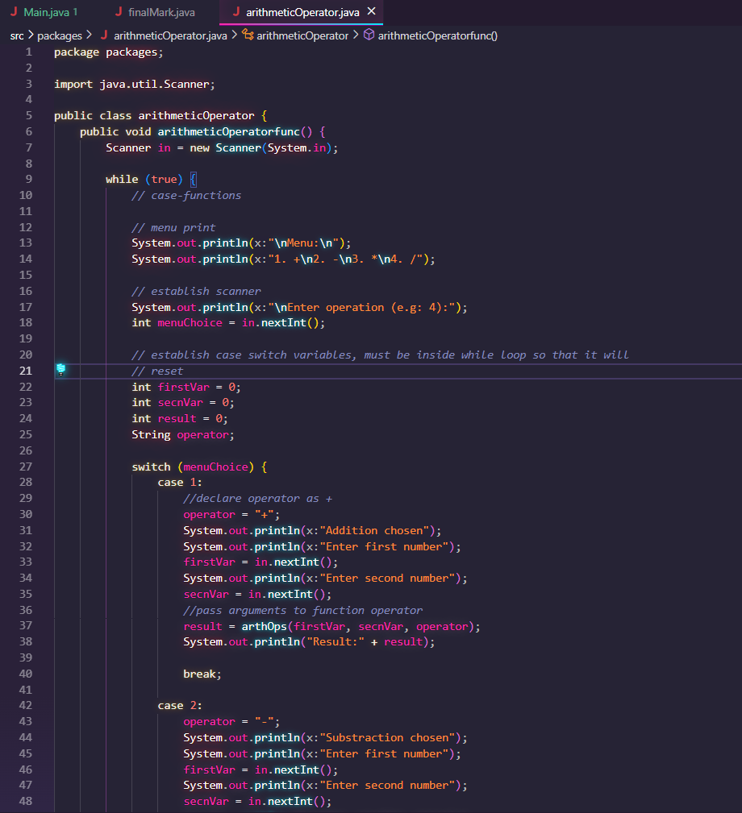 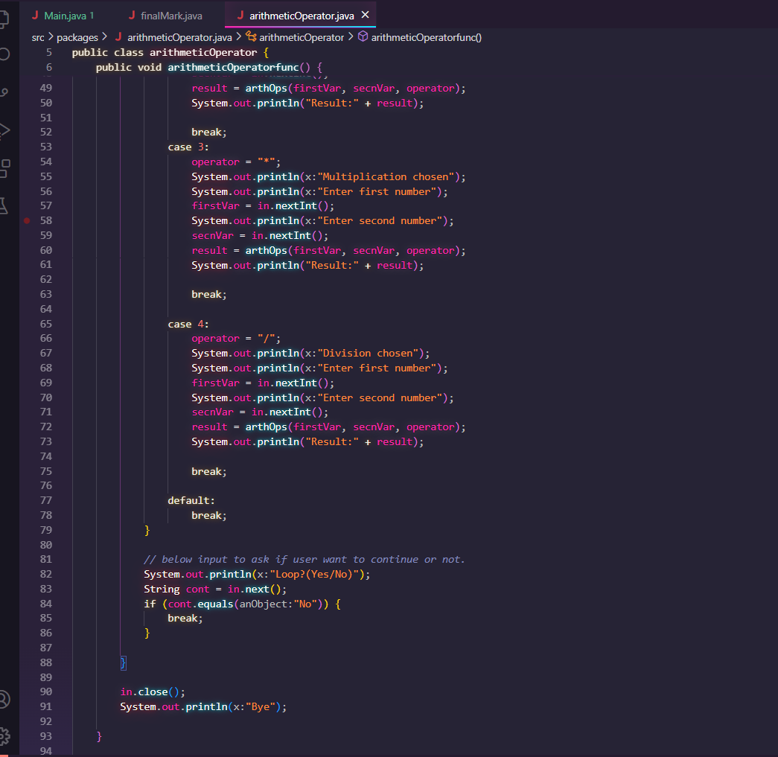

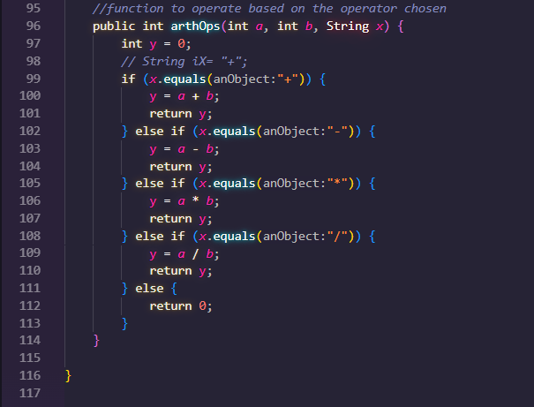

**OUTPUT**

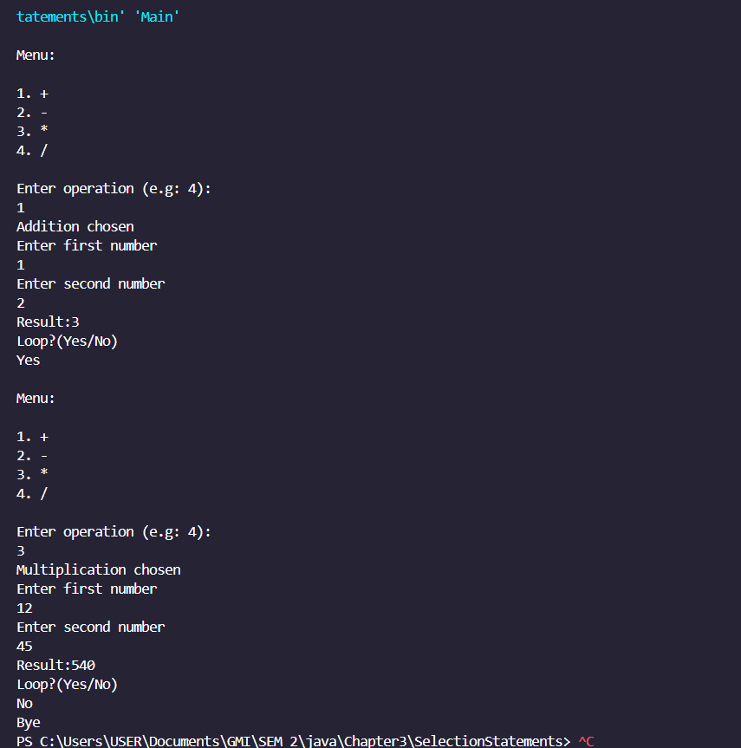

# Lab exercise 4

## File Structure

This Lab exercise is created with multiple packages, different task is created with different package. main function is in App.java .

Below is the file structure screenshot

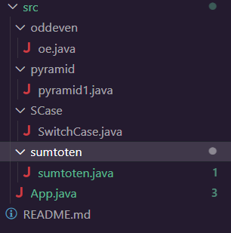

Here is the App.Java file code and Screenshot, function inside a method is called/uncommented on App.Java file to run each Question Tasks

// import java.util.Scanner;

import oddeven.*;

import sumtoten.sumtoten;

import pyramid.pyramid1;

import SCase.SwitchCase;

// from

public class App {

    public static void main(String[] args) throws Exception {

        // System.out.println("Hello, World!");

        // // task2

        sumtoten one = new sumtoten();

        one.sumtotenfunc();

        // //task3

        // oe calc = new oe();

        // calc.oddevenfunc();

        // //taskForNested1

        // pyramid1 twoPyramid = new pyramid1();

        // twoPyramid.pyramidbuild1();

        // twoPyramid.pyramidbuild2();

        //switchcase practice

        // SwitchCase sc1 = new SwitchCase();

        // sc1.sCase();

    }

}

## Question 1 Loop Structure to calculate sum of 1 to 10

**QUESTION**

Write a java program using “for”, “while” and “do while” structure to calculate the sum of 1 to 10.

**CODING**

Code from sumtoten.java

Text Form

package sumtoten;

public class sumtoten {

    public void sumtotenfunc() {

        // initialize variable for sum for each loop type example to 0

        int totalSumWhile = 0;

        int totalSumFor = 0;

        int totalSumdoWhile = 0;

        //this "i" variable is for while loop

        int i = 1;

        //tis "y" variable is for do while loop

        int y = 1;

        // While loop example below

        System.out.println("While loop below");

        while (i < 11) {

            //add the current increment to totalSumWhile.

            //If sum has previous value, it will add to the previous value

            totalSumWhile = totalSumWhile + i;

            //increment i by 1

            i++;

            //print each value of the sum from each loop

            System.out.println(totalSumWhile);

        }

        // For Loop example

        System.out.println("For loop below");

        //since for does not need to initiate increment variable outside,

        //it is declared below in the form of "x"

        for (int x = 0; x <= 10; x++) {

            //add the current increment to the Sum

            totalSumFor = totalSumFor + x;

            //below print each value of the sum

            System.out.println(totalSumFor);

        }

        // Do While loop example

        System.out.println("Do while below");

        do {

            //add the current increment for Sum

            totalSumdoWhile = totalSumdoWhile + y;

            System.out.println(totalSumdoWhile);

            //increment by 1

            y++;

        } while (y < 11);//since y is 11, to iterate until 10, it needs to be less 11.

    }

}

Screenshot the codes

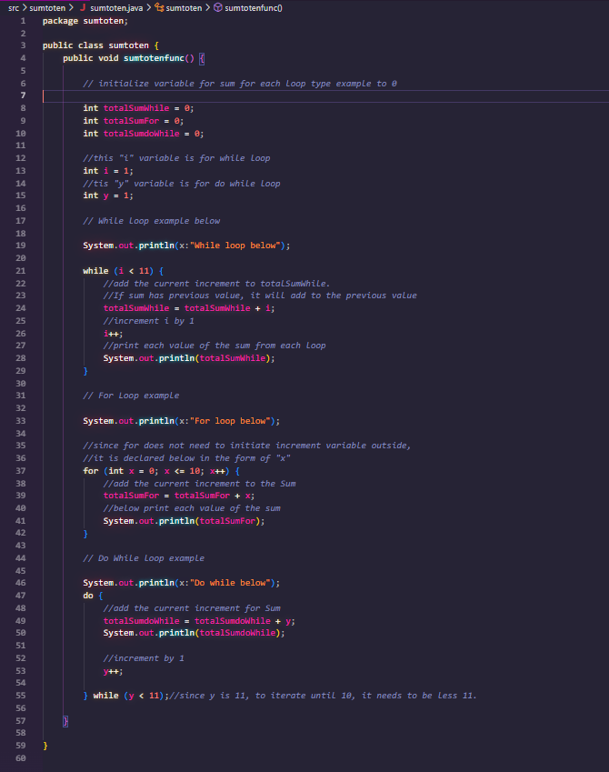

**OUTPUT**

Output of the screenshot

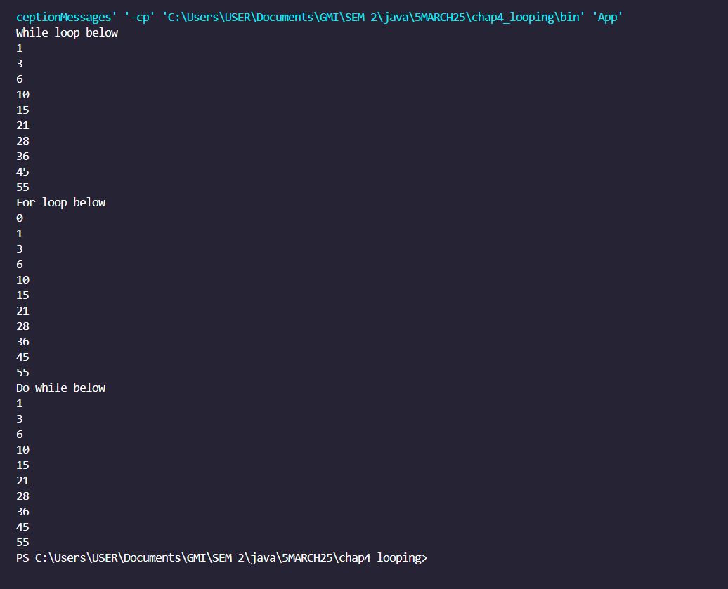

## Question 2 Sum of Odd and Even integers from 1 to 10

**QUESTION**

Write java program to display and sum up the even and odd integers within 1 to 10. Sum up and display the even and odd integers.

**CODING**

In text form:

package oddeven;

// Write java program to display and sum up the even and odd integers within 1 to 10. Sum up and display the even and odd integers.

public class oe {

    // declare class method/function to run program

    public void oddevenfunc() {

        int counter = 1;// this is the counter for each loop increment

        int totalOdd = 0;// sum variable for Odd

        int totalEven = 0; // sum variable for Even numbers

        // while counter lest than 11, meaning iterate from 1-10

        while (counter < 11) {

            // case for odd numbers,if it does not get remainder of 0 then

            if (counter % 2 != 0) {

                // if counter divided by 2, it will get remainder ,

                // so the counter is and odd number

                // hence add the current counter value to totalOdd

                totalOdd = totalOdd + counter;

            }

            if (counter % 2 == 0) {

                // case for even numbers, where it can be divided by 2

                // hence add the even number to totalEven

                totalEven = totalEven + counter;

            }

            // below to print the current values of the sum for each Odd and Even numbers

            System.out.println("\nOdd Sum \t:\t" + totalOdd);

            System.out.println("\nEven Count is \t:\t" + totalEven);

            //increment by 1

            counter++;

        }

        System.out.println("\n\nTotal for sum of even numbers :" + totalEven);

        System.out.println("Total for sum of even numbers :" + totalOdd + "\n\n");

    }

}

Screenshot from VS Code

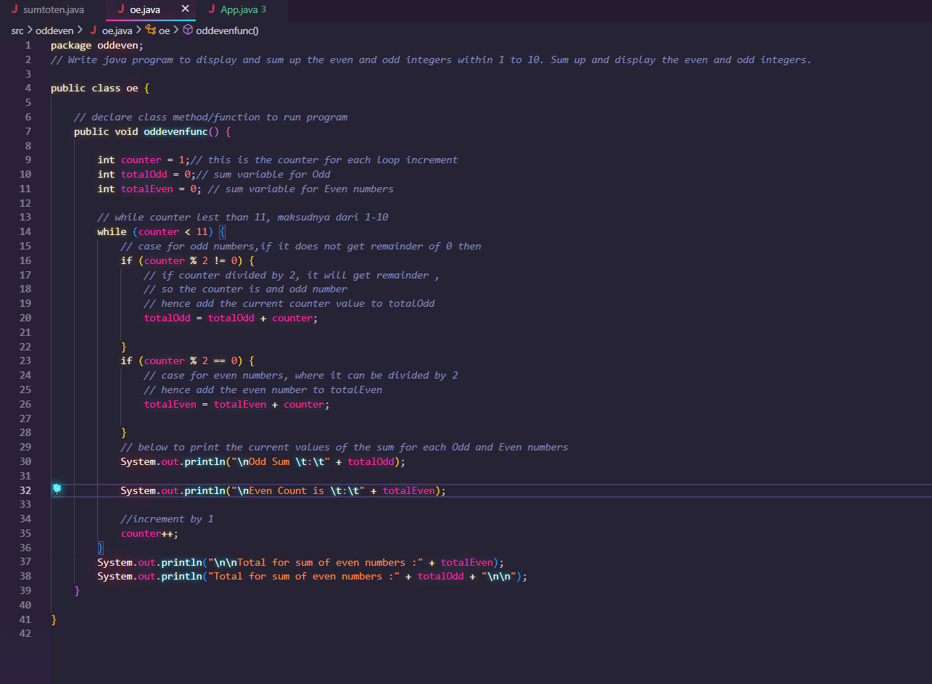

**OUTPUT**